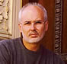
Suggestions from Steve: #69

A Musical Legacy

As we're approaching the holiday season, I seem to be in a nostalgic mood. I've been reflecting on my days as a percussionist in the Oshkosh High School Concert Band in Oshkosh, Wisconsin. I performed in that concert band under the musical direction of Dr. James Croft from 1970-1972 and was the percussion section leader in 1971-72. These were formative years during my musical development and thirty-five years later, I still value those musical memories.

Our band director, Dr. James Croft, was a musically-gifted and inspirational conductor. His conducting skills were impeccable and his superlative musicianship was evident in every musical gesture and nuance he articulated. As individuals within this performing ensemble, Dr. Croft held each player to the highest musical standard possible, and for this, I will always be in his debt. Being good was never enough--we aspired to musical greatness and remarkably, sometimes we felt as though we were indeed capable of achieving such rarefied musical glory. Even today, I rarely hear a high school concert/symphonic band that is as musically sophisticated as we were 'back in the day.'

This nostalgic musical reflection is not some self-indulgent 'sentimental journey' as the great Glenn Miller might have said, but an acknowledgement that sometimes you have the good fortune to have been a member of a musical ensemble that established a rich and esteemed musical legacy.

As young people, sometimes we don't possess the insight or wisdom to value our contributions to the musical tradition of an ensemble that we are currently a member of or have been involved in. Frequently, as older and wiser people, we'll reflect upon those days with greater insight and only then, do we finally realize how fortunate we were to have experienced such a glorious musical achievement. However, for those of you who are 'wise beyond your years' and do possess the 'mindfulness' (Buddhist concept) of being able to appreciate the very moment in which you are living, you will undoubtedly comprehend your contribution to your ensemble's musical legacy.

In hindsight, although I truly appreciated my high school concert band, it wasn't until years later that I grasped the importance of my contribution to the band's rich musical legacy. However, through the subsequent years as a music professional, I too, have been establishing my own musical legacy as a performer; composer; band leader and educator. I've tried to become more 'mindful' of what I'm trying to accomplish musically--creating and performing my original music that communicates to audiences and is artistically compelling, as well as being melodically and harmonically well-designed music that has an enduring quality.

I will always be grateful for the years I performed in the Oshkosh High School Concert Band in Oshkosh, Wisconsin(see pictures below). My great hope is that many other middle school and high school band students of their generation have a similar musical experience with their concert/symphonic band that I had with mine. If they do, they will be forever blessed and they too, will have contributed to their ensemble's rich musical legacy.

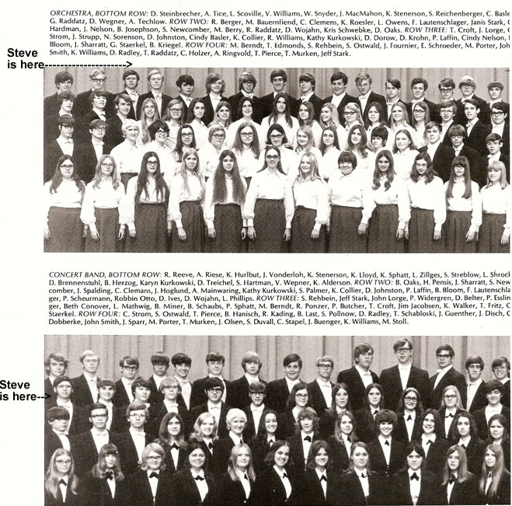

Copyright 2007 Steve Raybine
All Rights Reserved

